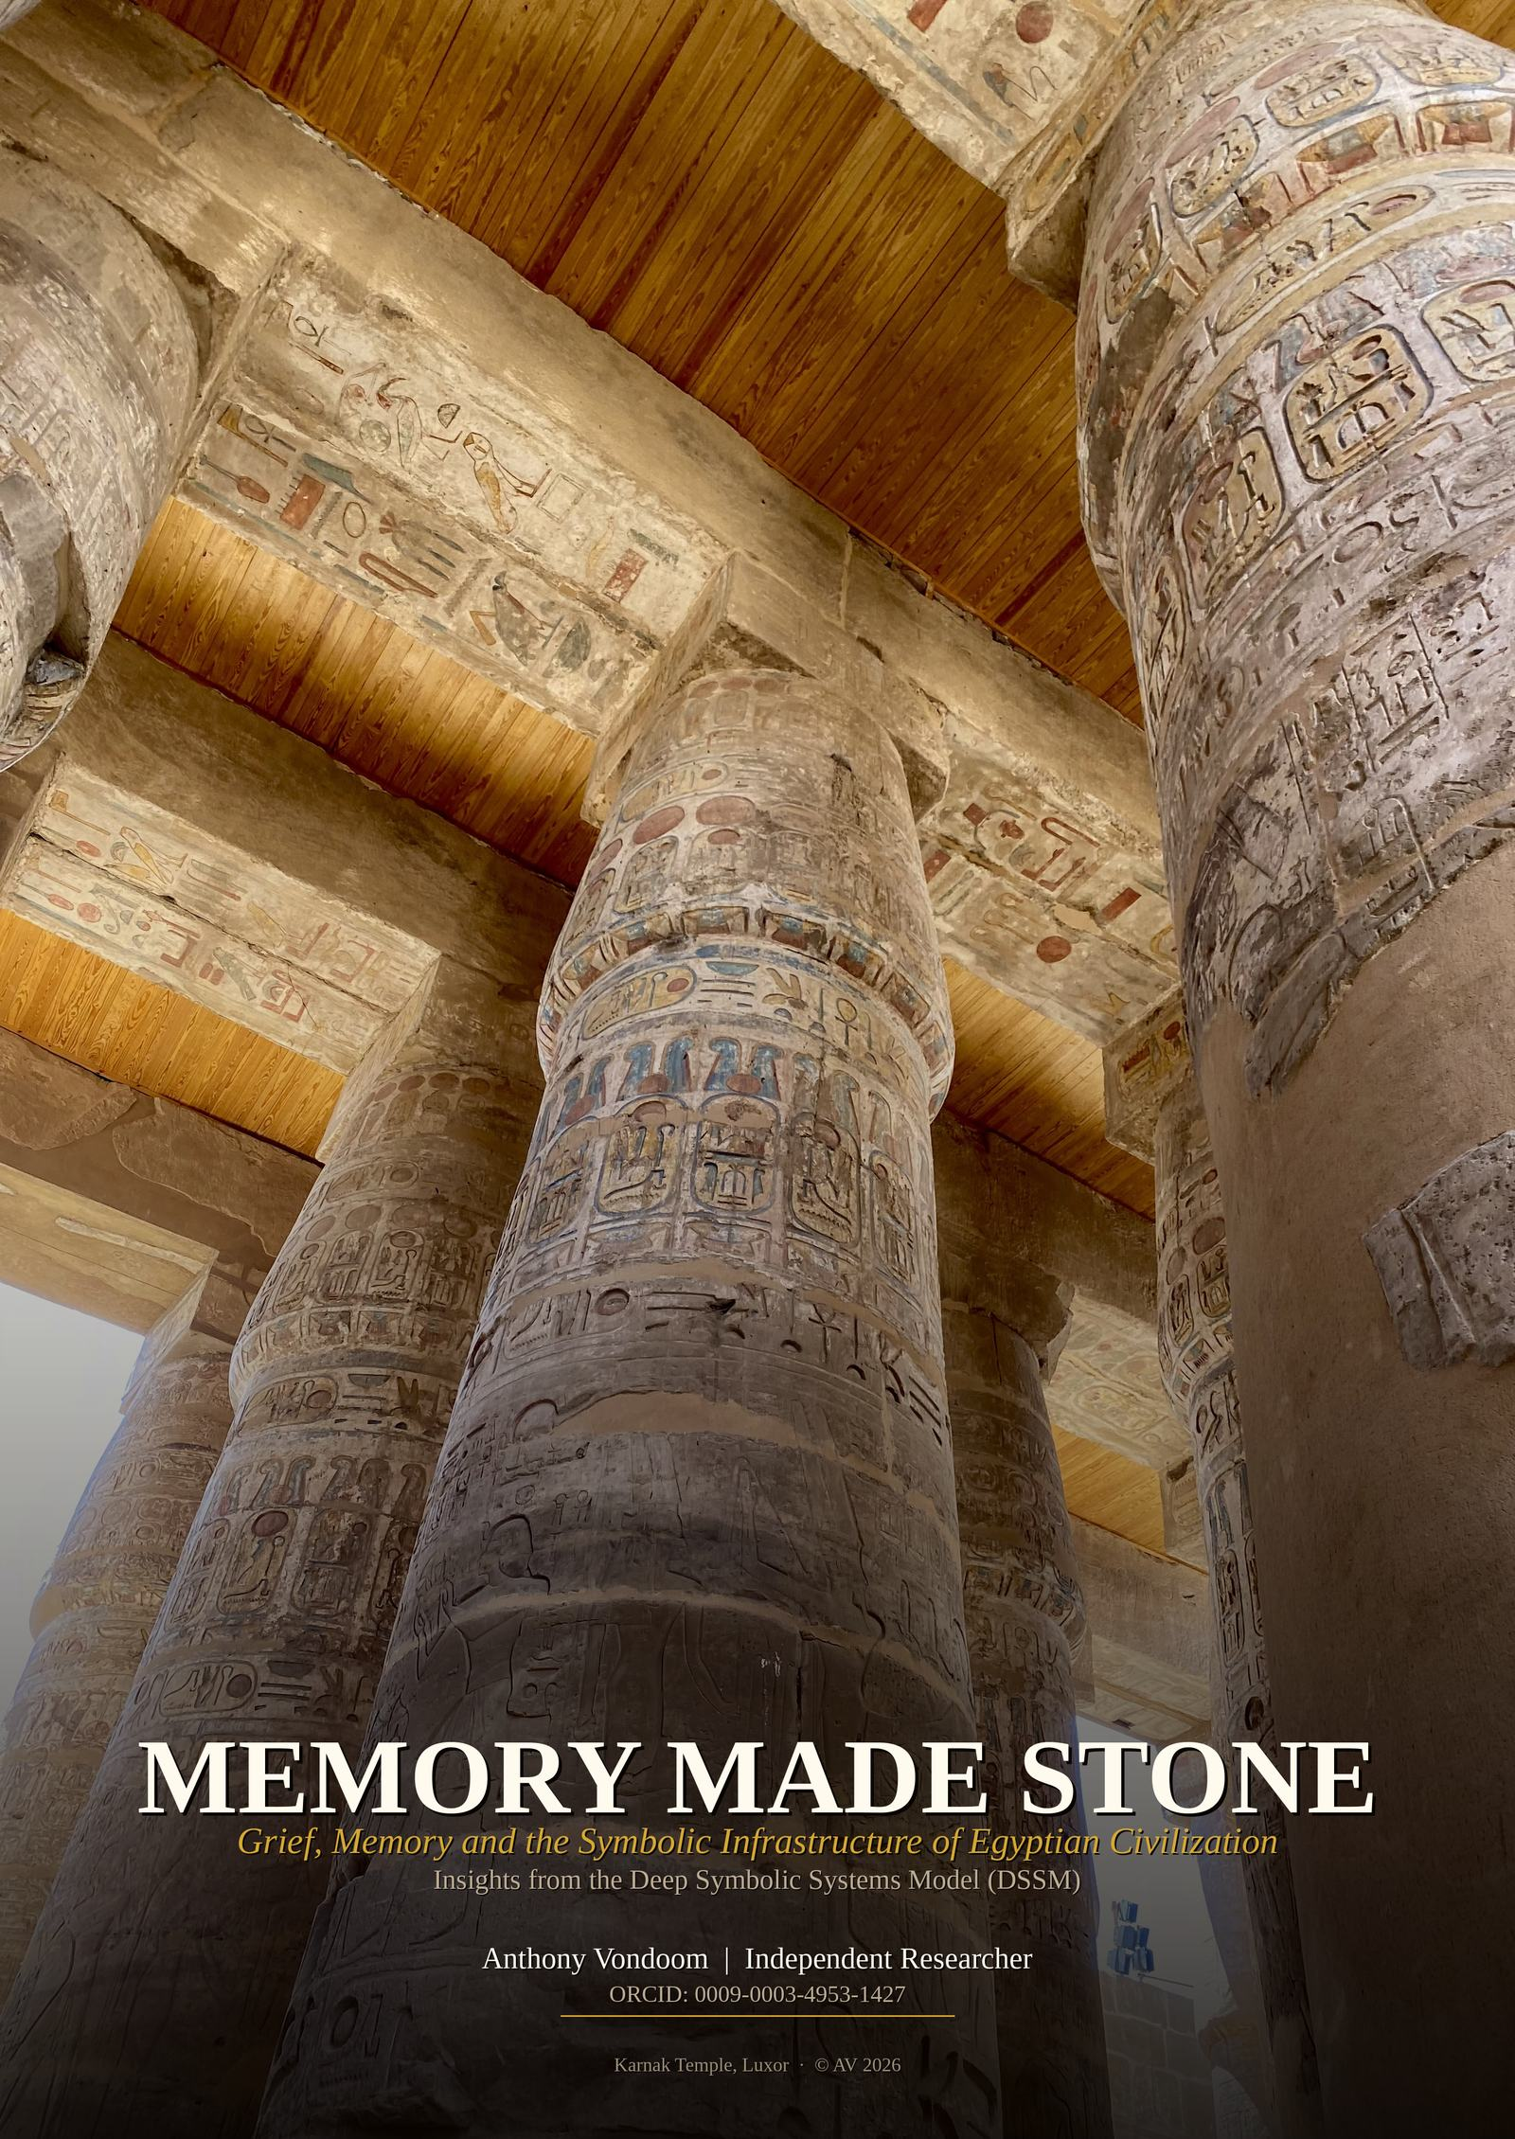

INTRODUCTION

The standard account of Egyptian civilization begins too late. It begins with the monuments, the hieroglyphs, the administrative apparatus of the pharaonic state — treating these as origins rather than as what they actually are: compressions. The late-stage material output of a symbolic system that had been accumulating in the neural architecture of Nile Valley communities for tens of thousands of years before the first stone was cut.
This essay applies the Deep Symbolic Systems Model (DSSM) — a cognitive-archaeological framework for understanding how symbolic systems stabilize across generations — to the specific case of ancient Egyptian mortuary practice and religious architecture.
The DSSM proposes that civilization advances through the recursive stabilization of embodied practices into durable symbolic systems, proceeding in four stages: Embodied Symbolic Familiarity, Ritualized Repetition, Material Amplification and Externalization, and Cognitive Offloading and Institutional Emergence. Monumentality and writing are, on this account, late-stage externalizations of pre-existing symbolic load — not origins. The central diagnostic tool is the Field Companion Protocol (FCP), which scores six observables on independent Evidence Strength (E) and Symbolic Specificity (S) axes, combining them through a minimum rule that prevents evidence robustness from masking symbolic ambiguity.
Two sites anchor the photographic and analytical evidence presented here. The first is the Valley of the Kings and the Giza Plateau — the canonical core of Egyptian monumental production. The second is the Oracle Temple of Amun at Aghurmi, Siwa Oasis — a site 500 kilometers west of Luxor, developed under different ecological pressures and a different political history, whose symbolic grammar is nonetheless structurally identical to what appears in the royal tombs. That convergence, across distance and divergent histories, is the central empirical finding of this essay.
The argument is not that these places are connected by administration or influence. The argument is that they share a common symbolic grammar stable enough to reproduce itself wherever the conditions for its operation are present — across space, across time, and across political regimes that came and went while the grammar endured.

I. The Chamber
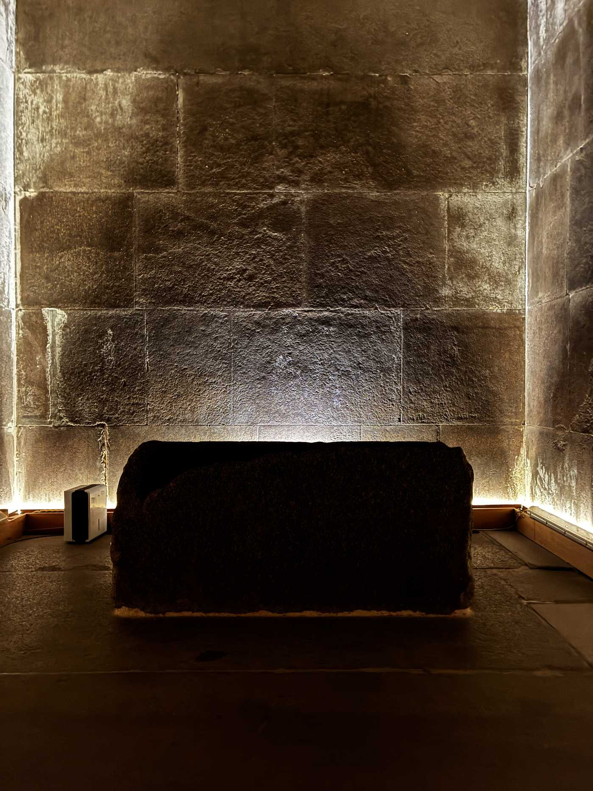
“The Kings Chamber” Interior of the Great Pyramid of Giza — Giza Plateau

This is the interior of the Great Pyramid Giza — the largest stone structure ever built, and one of the most precisely engineered. The descending and ascending corridors, the grand gallery, the king's chamber itself: every passage was cut with accumulated knowledge, not with calculation as we understand it. It has not shifted in four and a half thousand years.  The room speaks continuously, in a language assembled over tens of thousands of years, about the single subject that every human civilization has ever attempted to address: what happens when someone you love ceases to exist?  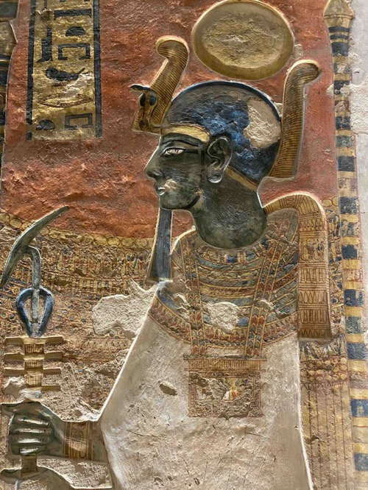 | 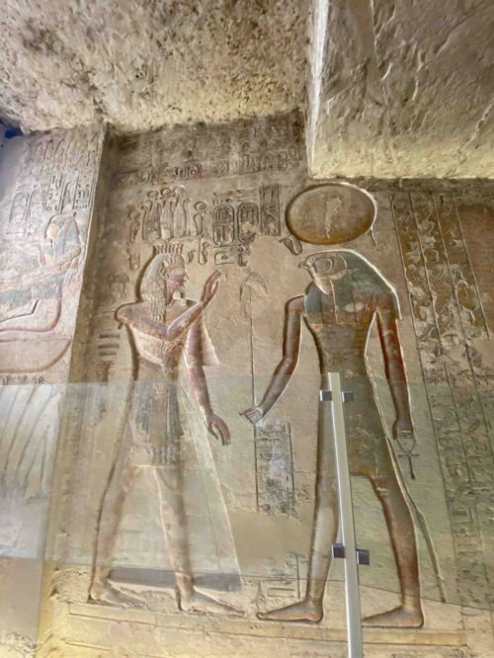  The wall is not decoration. It is a filing system. The most elaborate answer ever carved in stone to a question first asked, archaeologically speaking, roughly 92,000 years ago — when someone placed red ochre on a body, laid marine shells beside it, and walked away carrying the unbearable certainty that the person they loved was gone, and the equally unbearable suspicion that they were not.  This essay argues that Egyptian civilization — its gods, its monuments, its mortuary theology — is not anomalous. It is the most perfectly preserved instance of a cognitive process that runs continuously through human history from that first burial to this morning. The wall in that chamber is not mystical. It is logical.  It is what happens when a species that grieves, dreams, and transmits meaning across generations finally has enough stone to write everything down.

2. The First Gesture
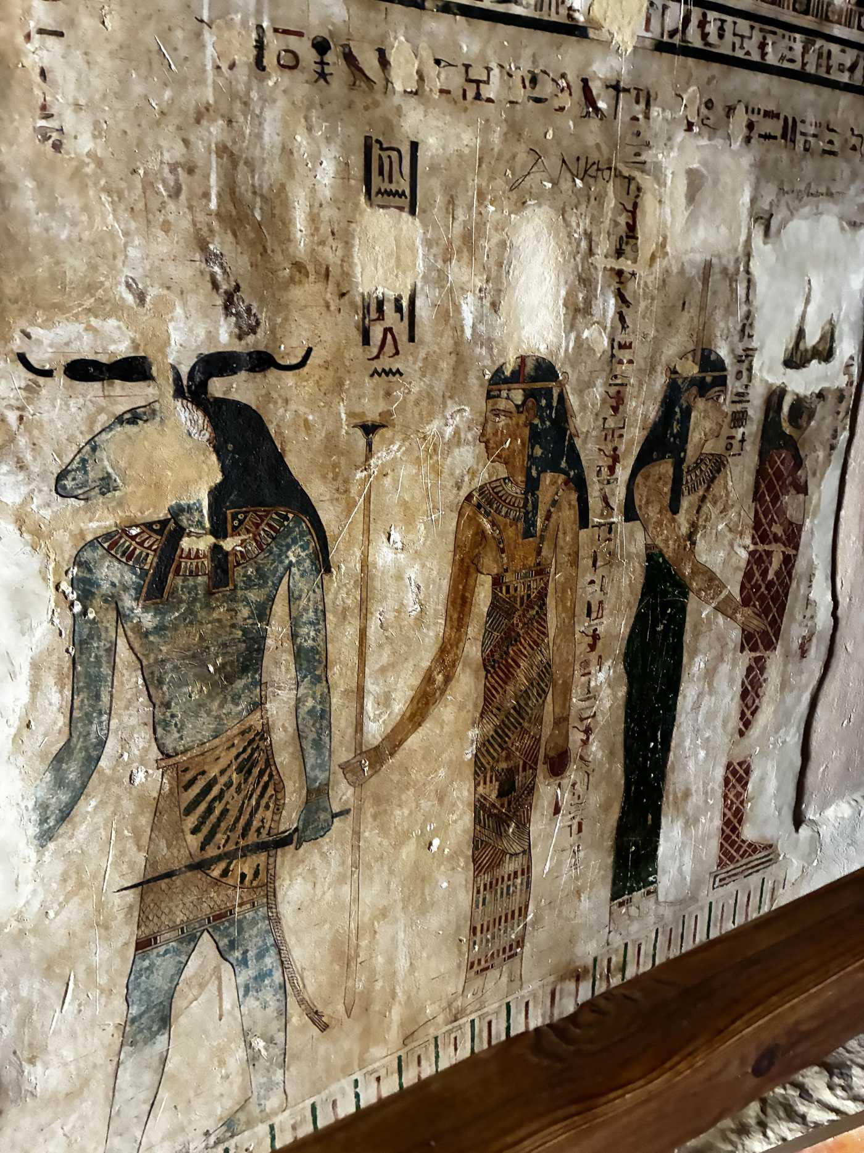
Temple of Amun, Aghurmi, Siwa Oasis — ancient stone at the edge of the Great Sand Sea

Around 92,000 years before the present, people in the Levant began burying their dead with ochre and marine shells. These were not food items. They were placed with care in positions that only make sense if you believe — or perhaps only need to believe — that the person in the ground is still, in some sense, a person. Earlier still, at Bruniquel Cave in France, Neanderthals arranged broken stalagmites into deliberate structures 176,000 years ago — non-utilitarian spatial organisation with no survival explanation. The figurative impulse appears independently in Sulawesi at least 51,200 years ago.  The neuroscience of what comes next is well established. Human beings dream. Every night, REM consciousness produces vivid, emotionally intense experiences that are phenomenologically indistinguishable from waking reality. A person appears. They speak. They feel as present as anyone in the room. Then you wake up, and they are the person you buried last season.  Without neuroscience, this is not metaphor. It is data. The most rational inference available — given the complete absence of counter-evidence — is that the deceased continues to exist somewhere accessible through altered states of consciousness.  Grief generates dream contact. Dream contact generates attributed intervention. Attributed intervention, repeated across generations, generates the ancestor who gives useful guidance — who becomes, over time, a protective spirit, and then a god.  The gods of Egypt were not invented. They were promoted. Osiris was understood to be the murdered king, the restored dead, the prototype of every human being who has ever been grieved. He was not an abstraction. He was a template — the proof that the promoted dead could be reached, could be joined, could restore what death had broken. | 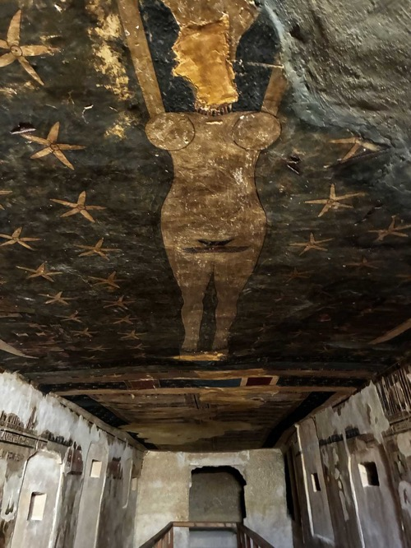  The Osiris myth — murdered by his brother Set, reassembled by Isis, avenged by Horus — is recognizable across millennia not because it is cosmologically sophisticated, but because every person who encountered it had lost someone to betrayal, had grieved someone who should not have died, had needed restoration of what was broken. The family structure of the Egyptian pantheon falls out of the merger process: when the ancestor cult of one community meets another, the two powerful dead agents are organized through the only hierarchical template available — kinship. The pantheon is a family because it was assembled from families.
III. The Long Rehearsal
Ten thousand years before the first stone was laid
The Qurta petroglyphs, carved into Nile-facing cliff faces around 19,000 to 15,000 BCE, are among the earliest evidence of symbolic accumulation in the Nile corridor. They are not primitive sketches. Motifs recur across geographically separated sites. Placement consistently favors cliffs overlooking river corridors. Scale and positioning maximize long-term visibility.  These were deliberate, labor-intensive, ecologically anchored acts of symbolic investment. They are the earliest detectable evidence of what the DSSM calls Embodied Symbolic Familiarity — the phase in which repeated physical engagement with consistent symbolic forms begins to consolidate shared meaning in neural architecture, independently of any single individual.  The logic is neurological before it is cultural. When the same actions are repeated under the same spatial and social constraints across multiple generations, they consolidate in the brain systems responsible for procedural memory — the kind of memory that persists across decades and is reliably transmitted through direct observation and co-participation. | A community that buries its dead in the same orientation, season after season, is encoding a shared program into the neural architecture of its members. The meaning is in the bodies before it is in the stones.  The Epipaleolithic aggregation sites at Wadi Kubbaniya, where mobile groups returned in planned congregation rather than opportunistic reuse, represent an error-correction mechanism: periodic gatherings that resynchronize symbolic conventions across sub-groups, preventing the gradual drift that isolation would otherwise introduce.  The Younger Dryas, a severe cold period between roughly 12,900 and 11,700 BCE, repeatedly compressed Nile Valley populations into refugia. Under resource-scarcity models, symbolic elaboration should have declined. Instead, Predynastic mortuary formalization intensified. Badarian cemeteries at Mostagedda and Hammamiya show consistent burial orientation and grave good regularity through documented ecological disruption. Structurally stabilized symbolic systems do not collapse under ecological pressure. They consolidate.

The meaning is in the bodies before it is in the stones. A community that buries its dead in the same orientation, generation after generation, writes a shared program into the neural architecture of its members.

IV. When Memory Exceeds What Bodies Can Hold
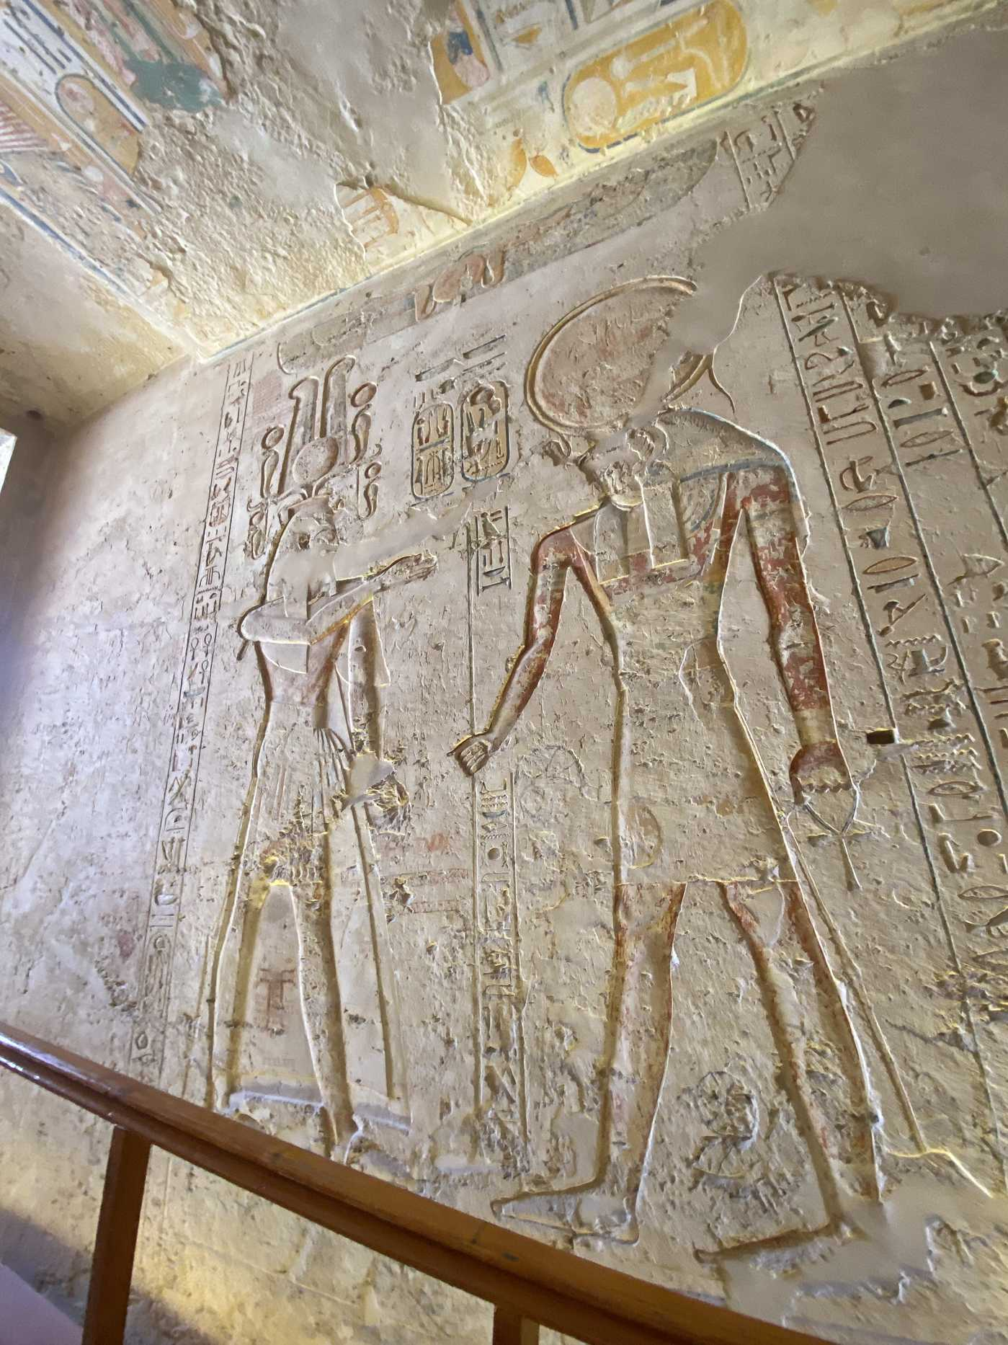
Valley of the Kings, Luxor

There comes a point in the life of any sufficiently complex symbolic system when the system exceeds the capacity of the people carrying it. The rituals become too intricate to memorize reliably. The genealogy of the gods becomes too long for any elder to recite in full. At this point, the system faces a choice that is not really a choice: externalize, or fragment.  The DSSM identifies this as the Stage 3 threshold. Research on social brain constraints places the upper limit of stable high-fidelity social networks at approximately 150 individuals, and communities consistently exceeding around 500 individuals face a transmission fidelity crisis requiring externalization of symbolic content into durable material media. The evidence from Hierakonpolis around 3500 BCE is diagnostic: large-scale installations, stratified ritual pits, and seasonal depositional cycles that require multi-community logistical coordination well beyond what any single leader or oral tradition could organize. | Computational corpus analysis has documented that sixty-eight percent of early hieroglyphic graphemic elements are traceable to prior material culture — motifs already established in ceramics, bone carvings, and ivory figurines centuries before the first administrative label was inscribed.  Writing did not invent Egyptian symbolic order. It codified an order that already existed. The Narmer Palette, dated to around 3100 BCE, is not the beginning of Egyptian symbolism. It is a compression of it — the late-stage output of a system that had been running for millennia.  The ceiling texts in the Valley of the Kings are activation sequences, not inscriptions. They encode ritual knowledge tested and refined across centuries of practice before it was ever carved in stone. The ceiling remembers what no single person could reliably hold.

Field Companion Protocol Scores — Egyptian Archaeological Sequence
Period | Primary Evidence | E avg | S avg | Total /12
Badarian 4500–4000 BCE | Standardized mortuary orientation, grave-good regularity. Thin evidence on both dimensions. | 1.3 | 0.9 | ~4.5
Naqada I 4000–3500 BCE | Black-topped ceramics, regional exchange networks, portable palettes, iconographic motifs spreading. | 1.7 | 1.5 | ~6.5
Naqada II 3500–3200 BCE | Hierakonpolis ceremonial complex, Tomb 100 iconography, multi-community ritual coordination. | 1.9 | 1.9 | ~8.5
Naqada III 3200–3100 BCE | Administrative hieroglyphs at Abydos, Narmer Palette, cylinder seal networks. | 2.0 | 2.0 | ~10
Early Dynastic 3100–2650 | Mastaba architecture, administrative papyri, royal cemetery programs, distributed authority. | 2.0 | 2.0 | ~11
Old Kingdom c. 2650 BCE | Djoser's Step Pyramid, worker settlements, full cosmological-political-ritual integration. | 2.0 | 2.0 | 12
E = Evidence Strength (0–2); S = Symbolic Specificity (0–2); Total = sum of min(E,S) across six FCP observables. Scores reflect genuine evidential variance, not confirmation of assumptions. The trajectory from 4.5 to 12 across 2,000 years is itself the central finding.

V. The Same Message, Elsewhere
Siwa Oasis · Oracle Temple of Amun, Aghurmi · 500 km west of Luxor
Siwa sits at the edge of the Great Sand Sea, deep in the Western Desert. It is separated from the Nile Valley by roughly 500 kilometers of open desert. The two sites developed under different ecological pressures, different political histories, and different degrees of state control.  The carvings at the Temple of Amun at Aghurmi tell the same story as the tombs of Luxor. This is the central empirical point of this essay: the symbolic content encoded in these walls — the posture of figures, the logic of exchange between the human and divine, the repertoire of sacred gesture — is not merely similar to what appears in the royal tombs. It is structurally identical.  Not because one copied the other. But because both are expressions of a symbolic system that had stabilized long before either site was built.  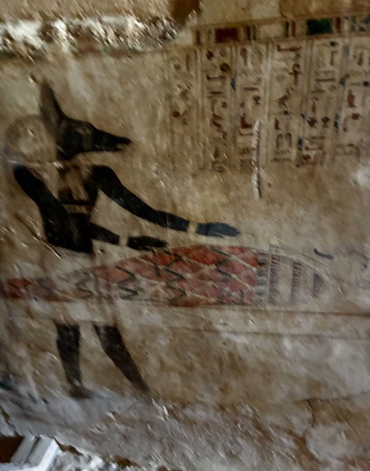 | 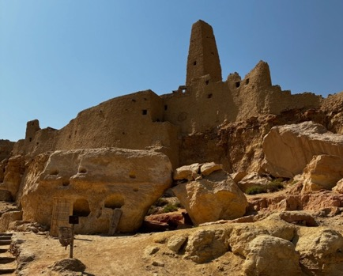  The oracle at Siwa was consulted by the most powerful rulers of the ancient world. Cambyses sent an army to capture it; it was lost in the desert. Alexander the Great made the journey to be confirmed son of Amun. Hannibal consulted it.  The oracle's authority was not derived from proximity to the Nile Valley administrative apparatus. It was derived from the depth and recognizability of the symbolic system it embodied — a system stable enough that a Macedonian general making a political decision about the legitimacy of his rule would cross hundreds of kilometers of desert to access it.  That is precisely what the DSSM predicts. A symbolic system that has stabilized across generations generates authority that is portable. It does not require continuous contact with its point of origin to remain legible. The grammar travels because it is already in the cognitive architecture of anyone trained within it.

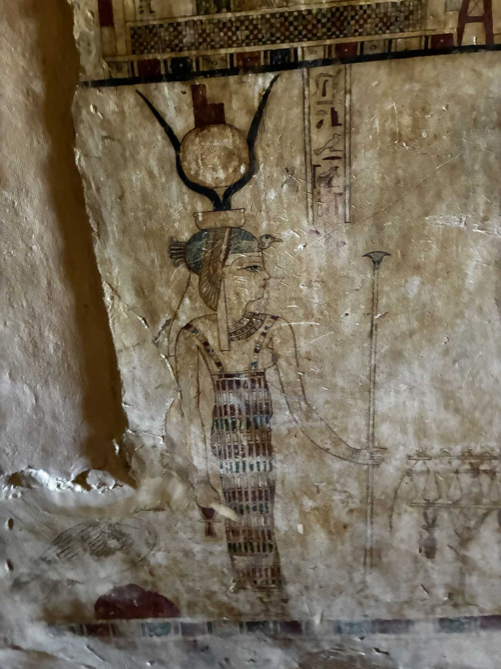
Temple of Amun, Aghurmi — Siwa Oasis

The figures carved at Siwa occupy the same canonical positions as those at Karnak. They perform the same gestures. They stand in the same relationships to one another — the offering figure extending toward the seated or standing divine recipient, the hieroglyphic labels identifying each party in the same formal register.  The wall at Siwa is not a provincial imitation of Luxor. It is a local instantiation of the same underlying grammar, produced by a community operating within the same symbolic system by different material and social means. | Look at the stone. The erosion at Siwa is far more advanced than at Luxor — the desert climate is harsher, the site less protected. But the underlying structure of the images is unchanged. Figures still face one another in the canonical exchange posture. The register lines still organize the visual field into hierarchical zones. What the elements mean locally varies. How they are organized does not.  This is what symbolic stabilization looks like when examined across space rather than across time. The same symbolic program, running at two sites separated by desert and by very different histories of political integration, producing the same output.

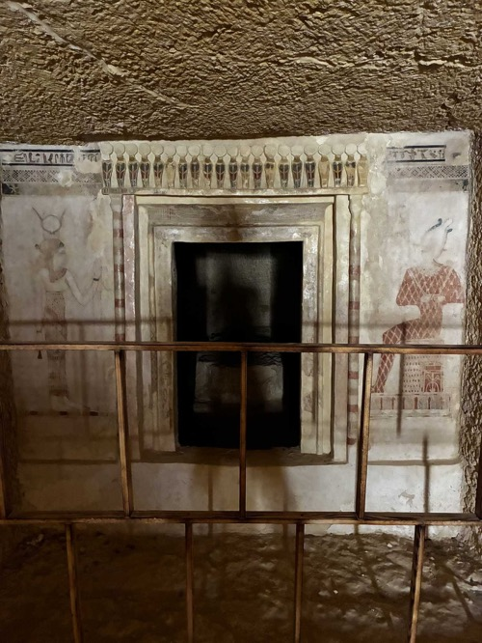 | 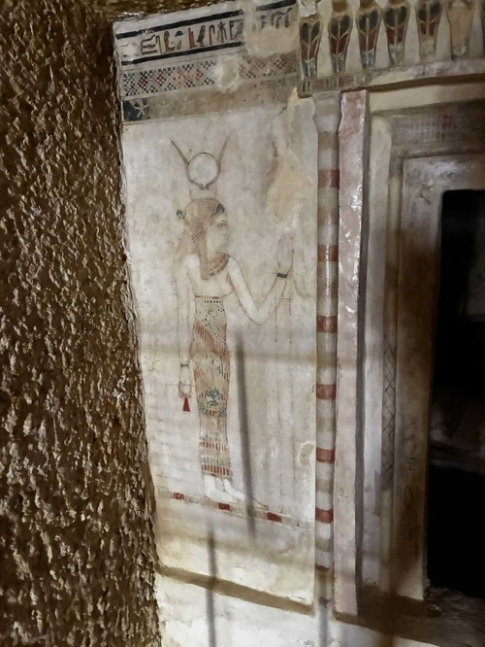

The figures at Siwa were not carved by priests trained at Karnak. The local tradition at the Oasis of Amun developed through oracle prestige, trade-route contacts, and the periodic presence of Libyan, Nubian, and eventually Greek populations who brought their own symbolic traditions into contact with the Egyptian one.  The result is a version of the grammar that shows local inflections — differences in carving style, in the specific iconographic combinations chosen, in the degree of color preservation. The grammar itself is unchanged. | Distance does not dilute symbolic stabilization. It tests it. What survives the test is structure: the relationships between elements, the logic of exchange, the spatial organization of sacred meaning.  The wall at the edge of the desert remembers the same things as the wall inside the mountain at Luxor. Not because of administration. Because of structure.

VI. Stone as Memory Infrastructure 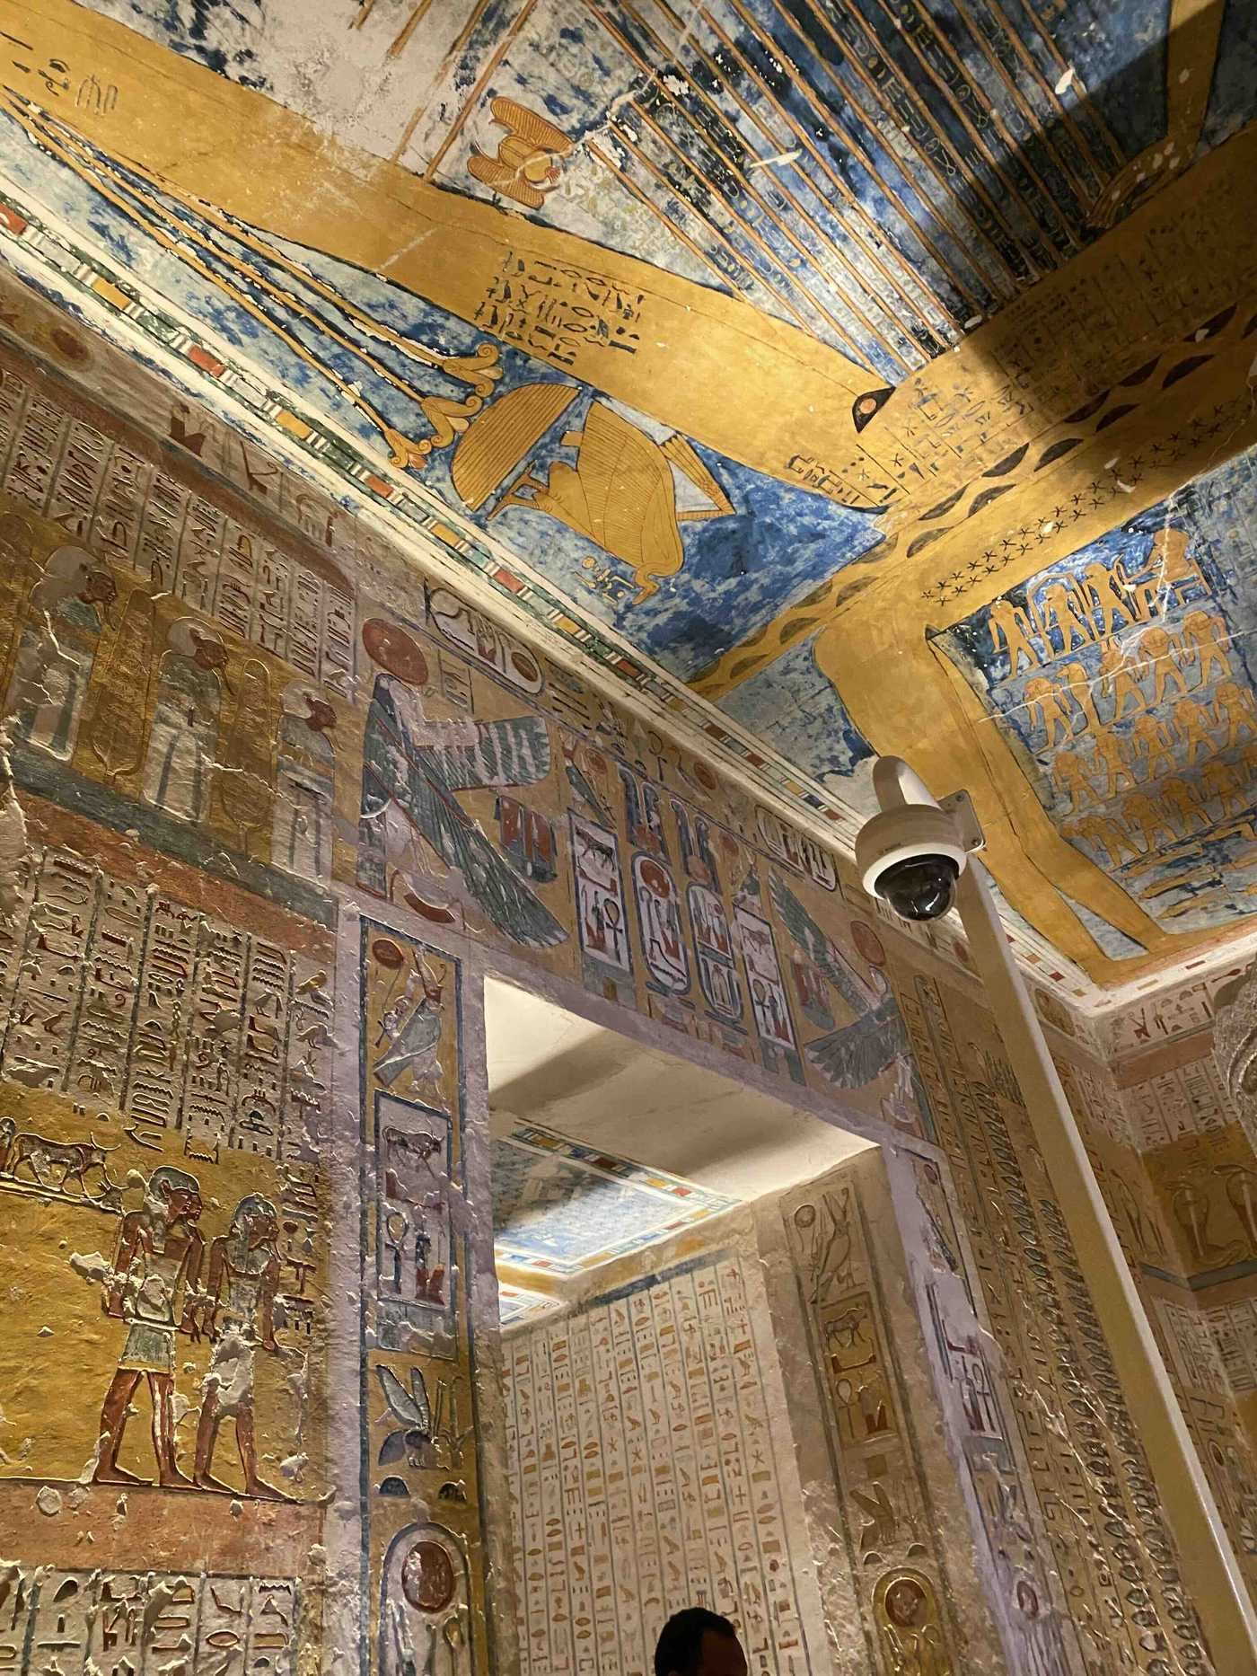

Royal tomb — Valley of the Kings, Luxor

Stand in front of the wall and try to read it as its makers intended it to be read — not as art history, not as religious curio, but as functional technology. The ceiling maps the night sky because the dead king needs to navigate it. The columns of text running floor to ceiling are activation sequences for the spiritual technology of resurrection, tested and refined across centuries of ritual practice before they were ever inscribed in stone.  The images of the gods are contact interfaces: standardized depictions of promoted ancestors whose intervention can be solicited through the correct protocol. The specific forms that externalization takes in Egypt are not arbitrary. Axial alignments echo the river-cliff orientations of Upper Paleolithic rock art. Enclosures replicate the structured aggregation zones of Epipaleolithic gathering sites. | Repetitive motifs — the solar disk, the falcon, the ankh — externalize cosmological redundancy previously sustained through oral and bodily practice. When you see the Eye of Horus carved into stone in the first century BCE, you are looking at a symbol whose cognitive lineage runs back through oral tradition to a time before any stone was carved.  The rapidity of monumental scaling in the Naqada III and Early Dynastic periods — from modest mastabas to Djoser's Step Pyramid in under three centuries — is frequently attributed to administrative innovation or surplus accumulation. Neither explains why the symbolic vocabulary encoded in those monuments remained structurally stable for over three thousand years across repeated political collapse.

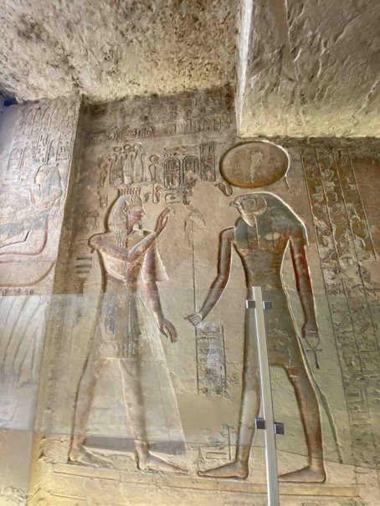 | The First and Second Intermediate Periods — genuine political catastrophes — did not erase Egyptian symbolic grammar. Political regimes changed. The gods did not. The axial orientation of tombs did not. The mortuary protocol did not. That stability is not administrative. It is deeper than administration.  It is what happens when symbolic meaning has been consolidated in neural architecture across hundreds of generations before any monument was built. The monument leverages pre-state symbolic authority, not top-down coercion invented by the state.  The twenty thousand workers later mobilized for pyramid construction were not coerced laborers in the modern sense. The archaeological evidence from their settlement — bakeries, breweries, and medical facilities — suggests a workforce organized under symbolic, not purely economic, obligation.

VII. Cross-Media Redundancy

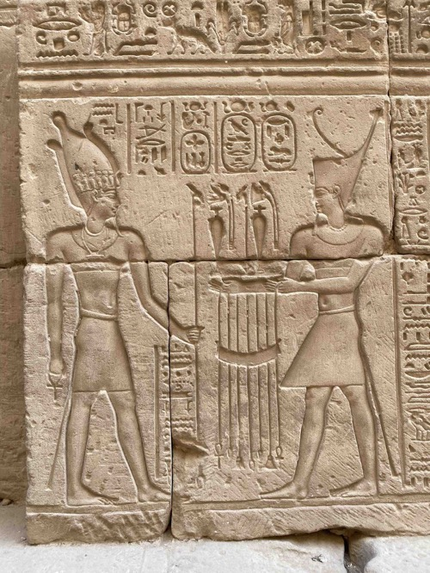  Karnak Temple, Luxor | 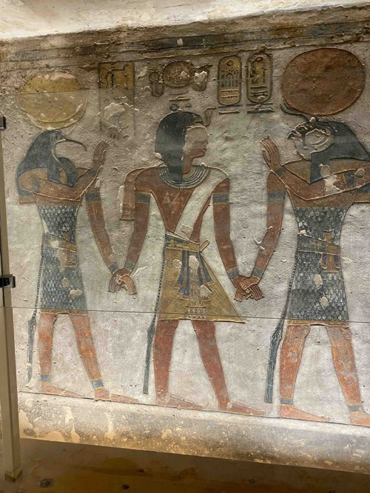  Valley of the Kings, Luxor

One of the diagnostic markers of a deeply stabilized symbolic system is cross-media redundancy: the same symbolic content expressed in multiple independent media simultaneously, so that the loss of any one medium cannot destroy the meaning. Egyptian civilization was, from early in its development, a study in redundancy engineering.  The Isis myth was expressed simultaneously in oral tradition, in painted tomb relief, in carved stelae, in faience amulets, in papyrus text, in temple architecture, in ritual performance, and in the bodies of priests who enacted it in ceremonial context. No single medium was the master copy. | This is why Akhenaten's monotheistic revolution failed. Not primarily for political reasons, though it had political consequences. It failed because it attempted to delete redundancy — to concentrate symbolic authority in a single divine figure — in a system whose entire architecture was built around distributed redundancy.  When the political support for Atenism collapsed, the distributed system reasserted itself. You cannot overwrite a symbolic system encoded in the neural architecture of an entire civilization. You can suppress its surface expression. The system waits.

VIII. The Final Externalization
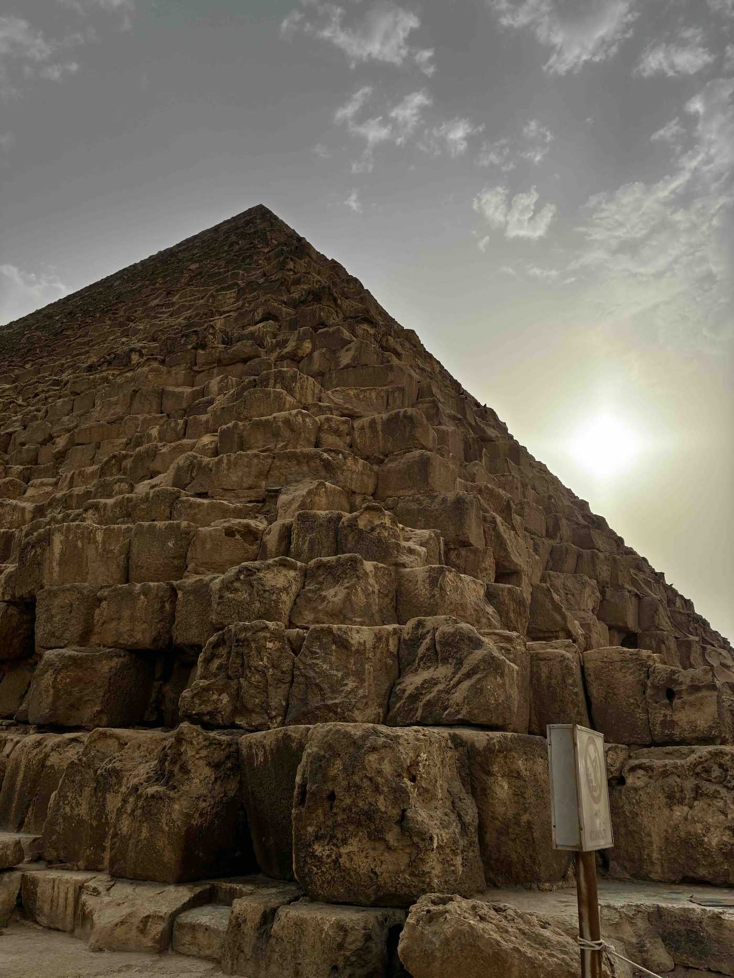
The Great Pyramid, Giza Plateau

The pyramid is the hardest thing to explain if you start from administration and surplus. It is the easiest thing to explain if you start from grief.  The pyramid fixes in permanent, maximally durable material the axial orientation that Egyptian communities had been performing in burial since the Predynastic period. It creates an indestructible mnemonic anchor — the Nile-facing cliff made permanent, the aggregation site made immortal, the sacred space made immune to political collapse.  The pyramidal form encodes the primordial mound — the first land to emerge from the waters of chaos in Egyptian creation cosmology — and points toward the circumpolar stars that never set, that never die, that represented the souls of the glorified dead. | Every element of the pyramid complex is a solved problem in symbolic engineering. The Pyramid Texts — among the oldest religious literature in the world — encode in hieroglyphs the spells that had been transmitted orally for centuries before they were carved into stone.  Cleopatra VII, who died in 30 BCE and was the last pharaoh to speak Egyptian, operated on symbolic structures stabilized millennia before the Ptolemaic dynasty arrived. She performed the rituals in their canonical forms. The gods she invoked were the promoted dead of a lineage stretching back to Qafzeh and beyond. The cognitive infrastructure was so deeply consolidated that a Macedonian Greek ruling family found it easier to adopt the Egyptian symbolic grammar than to replace it.  The walls remember longer than any dynasty.

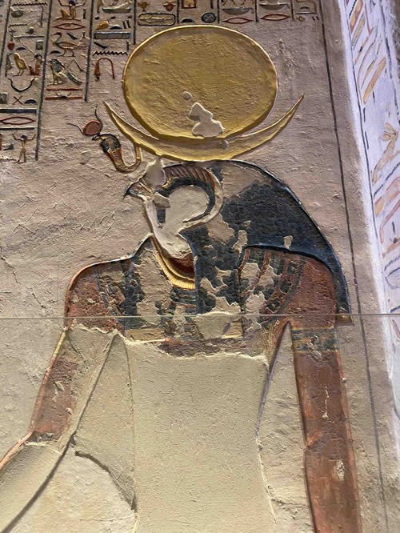  Valley of the Kings, Luxor | 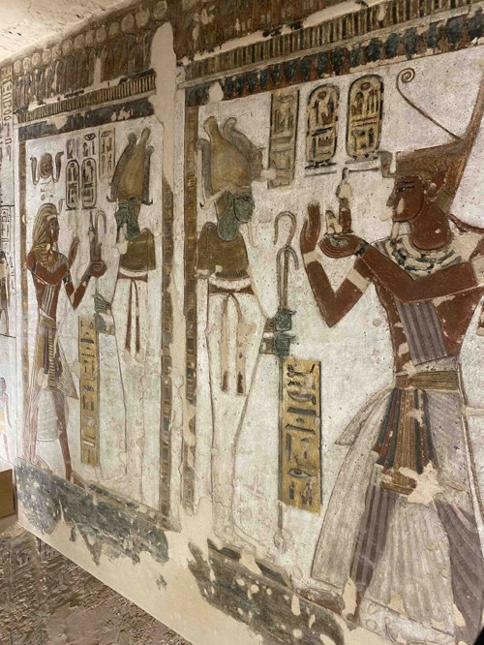  Valley of the Kings, Luxor

IX. What It Means
A 2024 Pew Research Center survey across eleven East and Southeast Asian nations found that majorities in nearly every country regularly perform rituals to honor deceased ancestors — burning incense, offering food, maintaining grave sites. In Vietnam, 96% of adults reported burning incense for ancestors in the previous twelve months.  These are not people practicing a foreign tradition. They are running the same cognitive program as the person who placed ochre on a body at Qafzeh 92,000 years ago. The medium changed. The need, the mechanism, and the emotional transaction did not.  Egyptian civilization is the most elaborately preserved instance of what happens when that universal human program encounters a specific set of enabling conditions: a stable river-corridor ecology, an ecological stress regime that intensified rather than destroyed ritual investment, and sufficient temporal depth for the system to reach a degree of consolidation capable of surviving three millennia of political history. Cultural evolutionary research confirms the functional logic: ritual engagement with shared beliefs cues group cohesion, facilitates trust, and resolves the free-rider problem that threatens long-term collective systems. | The Siwa temples and the royal tombs of the Valley of the Kings are not near one another in time or in space. They were built under different political systems, by different communities, using different materials, for different local purposes. What they share is not a common administration. What they share is a common symbolic grammar — one stable enough to generate the same postures, the same exchange logic, the same spatial organization of sacred meaning, across 500 kilometers of open desert.  That convergence is not coincidental. It is what a stabilized symbolic system does. Once symbolic load has been consolidated into the neural architecture of a culture — once the meaning is in the bodies, in the objects, in the spatial arrangements, in the practiced gestures — it no longer requires central coordination to reproduce itself.  The wall at the edge of the desert remembers the same things as the wall inside the mountain. They share not an administration. They share a grammar.

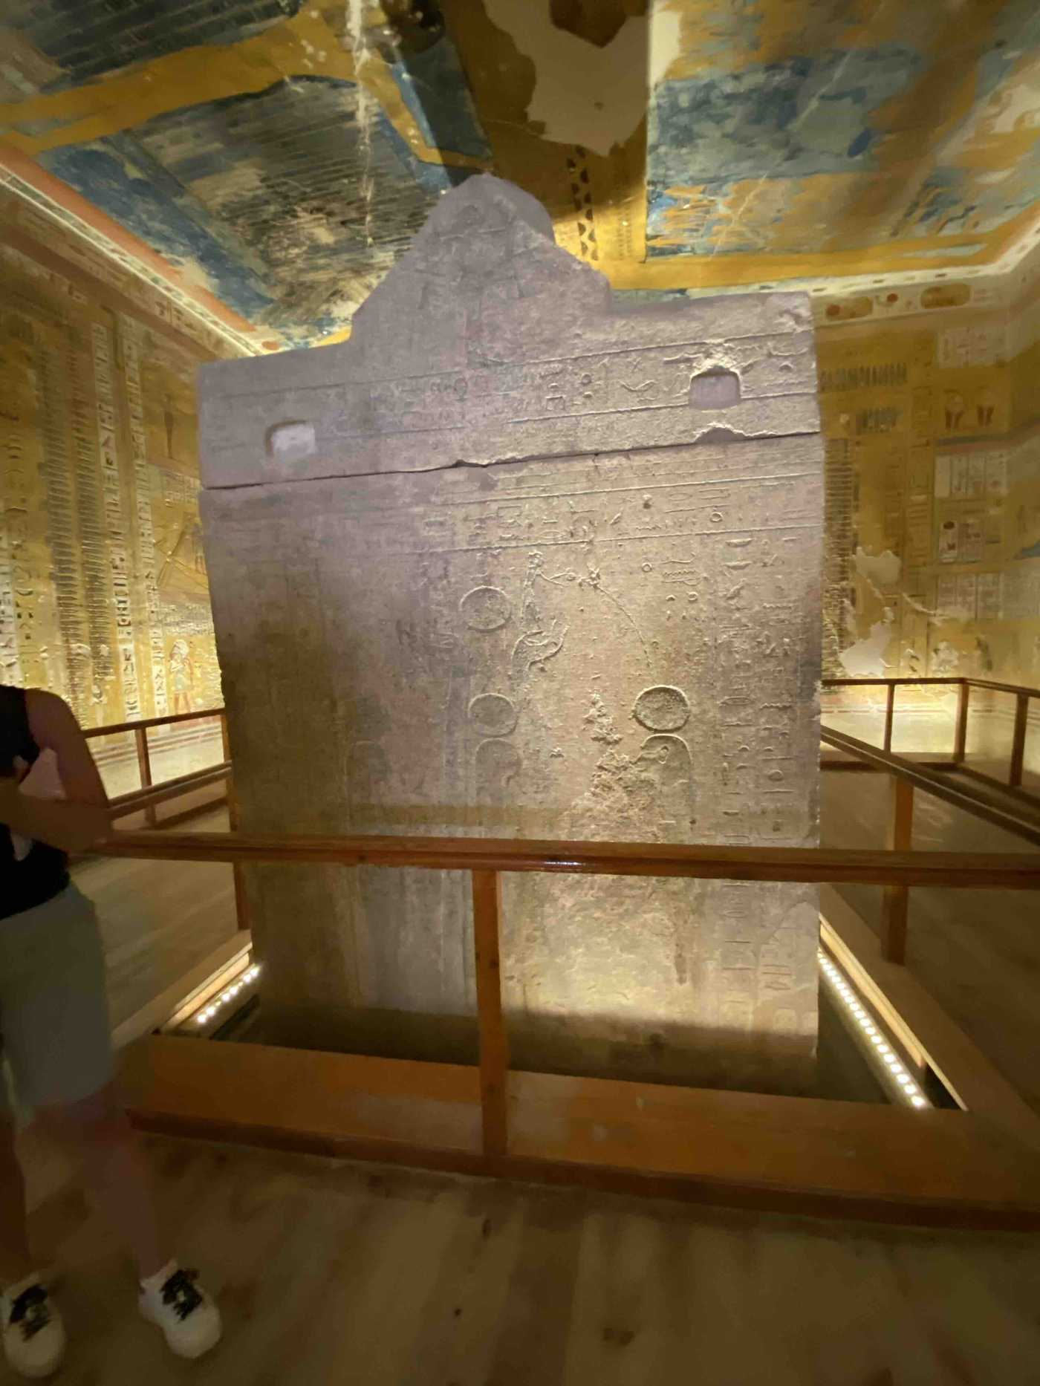
Royal sarcophagus in situ — Valley of the Kings, Luxor

When you stand in that chamber, in the silence of worked stone, in the room where every surface has been committed to the project of keeping someone alive in the memory of the cosmos — you are not looking at something alien. You are looking at what you yourself would do, if you had three thousand years and an infinite supply of granite, and someone you loved had died, and you could not bear the thought that the love had simply stopped.
The wall remembers. It always has. So do you.

Relevance to UN Sustainable Development Goals

SDG 4 — Quality Education
This research contributes to SDG 4 by advancing interdisciplinary methodology in cognitive archaeology and providing an operationalized, falsifiable framework — the DSSM — that can be taught, tested, and refined across archaeological specialisms. The cross-cultural analysis of symbolic stabilization offers a transferable model for understanding how complex knowledge systems are transmitted and maintained across generations, with direct relevance to curricula in archaeology, cognitive science, and history.
SDG 10 — Reduced Inequalities
Demonstrating the common cognitive substrate shared across geographically and politically distinct Egyptian sites — from royal Luxor to the marginal oasis of Siwa — challenges narratives that attribute civilizational achievement solely to centralized elite production. The DSSM shows that symbolic infrastructure was distributed, community-embedded, and resilient across social hierarchies, providing an evidence-based foundation for questioning hierarchies of cultural worth.
SDG 11 — Sustainable Cities and Communities
This research illuminates the cognitive and symbolic preconditions of early urbanism and institutional emergence in the Nile Valley, contributing to broader understanding of how human communities develop durable collective structures. The finding that symbolic stabilization precedes and enables institutional complexity offers foundational insight into the cultural conditions for long-term community resilience.
SDG 16 — Peace, Justice and Strong Institutions
The analysis of how stable, legitimate institutions emerge from symbolic stabilization — across diverse communities including the politically marginal Oracle at Siwa — provides a mechanistic account of institutional authority that does not depend on coercion. Understanding the cognitive foundations of shared symbolic grammar across communities separated by distance and political history offers a framework for thinking about cross-cultural recognition and the common roots of human institutional life.

All photographs © Anthony Vondoom, 2026. All rights reserved. Locations: Valley of the Kings, Giza Plateau, Karnak Temple, Siwa Oasis.
AI assistance: Claude Sonnet 4.6 (Anthropic) provided editorial and structural support. All intellectual content, theoretical framework, and conclusions are solely those of the author
Bibliography

Bar-Yosef Mayer, D. E., Vandermeersch, B., & Bar-Yosef, O. (2009). Shells and ochre in Middle Paleolithic Qafzeh Cave, Israel: indications for modern behavior. Journal of Human Evolution, 56(3), 307–314.
Dunbar, R. I. M. (1992). Neocortex size as a constraint on group size in primates. Journal of Human Evolution, 22(6), 469–493.
Dreyer, G. (1998). Umm el-Qaab I: Das prädynastische Königsgrab U-j und seine frühen Schriftzeugnisse. Deutsches Archäologisches Institut Abteilung Kairo. Philipp von Zabern.
Fakhry, A. (1944). Siwa Oasis: Its History and Antiquities. Government Press, Cairo.
Friedman, R. (2008). Excavating Egypt's Early Kings: Recent discoveries in the elite cemetery at Hierakonpolis. In B. Midant-Reynes & Y. Tristant (Eds.), Egypt at its Origins 2 (pp. 1157–1194). Peeters.
Graybiel, A. M. (2008). Habits, rituals, and the evaluative brain. Annual Review of Neuroscience, 31, 359–387.
Hassan, F. A. (1985). Radiocarbon chronology of Neolithic and Predynastic sites in Upper Egypt and the Delta. African Archaeological Review, 3, 95–116.
Henrich, J. (2015). The Secret of Our Success: How Culture Is Driving Human Evolution, Domesticating Our Species, and Making Us Smarter. Princeton University Press.
Huyge, D., Watchman, A., De Dapper, M., & Marchi, E. (2001). Dating Egypt's oldest "art": AMS 14C age determinations of rock varnishes covering petroglyphs at el-Hosh. Journal of Archaeological Science, 28(10), 1017–1025.
Jaubert, J., et al. (2016). Early Neanderthal constructions deep in Bruniquel Cave in southwestern France. Nature, 534, 111–114.
Kuhlmann, K. P. (1988). Das Ammoneion: Archäologie, Geschichte und Kultpraxis des Orakels von Siwa. Deutsches Archäologisches Institut. Philipp von Zabern.
Malafouris, L. (2013). How Things Shape the Mind: A Theory of Material Engagement. MIT Press.
Oktaviana, A. A., et al. (2024). Narrative cave art in Indonesia by 51,200 years ago. Nature, 631, 814–818.
Pew Research Center. (2024). Ancestor veneration and death beliefs, practices in East Asia. https://www.pewresearch.org/religion/2024/06/17
Purzycki, B. G., et al. (2016). Moralistic gods, supernatural punishment and the expansion of human sociality. Nature, 530, 327–330.
Stevenson, A. (2016). The Egyptian Predynastic and state formation. Journal of Archaeological Research, 24, 421–468.
Vondoom, A. (2025). The Deep Symbolic Systems Model (DSSM) — A Cognitive-Ritual Framework for Early Monumentality and Cultural Continuity. OSF Preprints. https://doi.org/10.17605/OSF.IO/MRZFU
Vondoom, A. (2025). The Rehearsed Sacred: Belief as the Cognitive Foundation of Human Civilization. Zenodo. https://doi.org/10.5281/zenodo.20036012
Vondoom, A. (2026). Cognitive Foundations of Early Egyptian Civilization: Insights from the Deep Symbolic Systems Model. IWNW: Journal of the Faculty of Archaeology, Ain Shams University,work in progress
Vondoom, A. (2026). Deep Symbolic Stabilization Along the Nile: An Egypt-Based Case Study of the DSSM.
Whitehouse, H. (2009). Modes of religiosity: Towards a cognitive explanation of the sociopolitical dynamics of religion. Method & Theory in the Study of Religion, 14(3–4), 293–315.
Wilkinson, T. A. H. (1999). Early Dynastic Egypt. Routledge.
Wilkinson, R. H. (2003). The Complete Gods and Goddesses of Ancient Egypt. Thames & Hudson.
.

